
January 2011 Volume V, No. 1
Among Friends

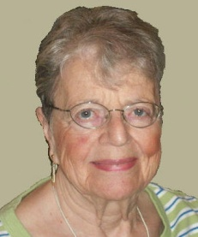  Joan Schwartzman | PRESIDENT’ S MESSAGE  by Vice-president Marion Damick  When asked to fill this space due to FOL President Joan Schwartzman being ill, I thought, as usual, of writing about dire tidings for libraries in the future  and how much that will affect one and all. | 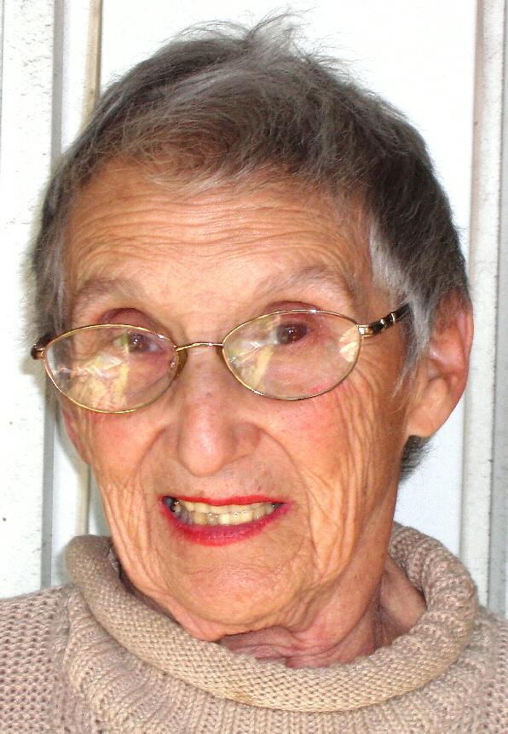  Marion Damick |   WELCOME,  NEW MEMBERS  Bonita Allen  Kimberly Bankston  Mary Carrasco  Alyssa Copeland  Beverly Darwin  Allie Giel  Paul Krystosek  Michelle McCarthy  Rebecca O’Hara  Bill Playton  Evan Riley  Sara Sachs  Zachary Selekmen  Lisa Zupsic
But, by chance, I attended a social dinner at a local restaurant for a non-profit board of which I'm a member. There I was, sitting among a number of young career women, almost all of whom were in positions of high authority. Many subjects were discussed, but what interested me most was the surprise subject of books. After discussing HBO shows, they turned the discussion to what they were reading and exchanged comments on books vs movies, with suggestions of what books they recommended. Then, one exclaimed that each Sunday she goes to the Squirrel Hill library (" so close I can walk") and picks up three or four books. Another frequents a library in Sewickley. Aha! I thought -- we have been focusing on how important reading is to the young; we've forgotten the career women who do read. The libraries are a vital part of everyone's life!

A brief reminder of the excellent art exhibit at the Carnegie, which focuses on photos of people throughout the world, all reading. Not to be missed are the books on the tables in the same room--all involved with reading. As my son says, "Visit the photos of readers; it's a novel idea."

MINI SALE NEWS  by Pat Bender  As I write this, the books from the November sale are still displayed in the Marlborough Street entrance, and selling very well. The official 4-day Holiday Shopping sale netted $2000, and more will be realized when the receipts from the ongoing sale are l | 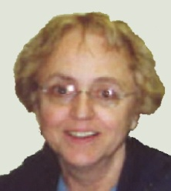 | It is our choices, Harry, that show what we truly are,  far more than our abilities.  J. K. Rowling
added. Many, many thanks for your support.  "Everything Old is New Again" in January. We will be selling famous books from days gone by, literary classics, and any of the like-new books that are left. All of these will be “Buy 2, Get 1 FREE”. There will also be some sets of books and nicely bound classics, at full price. The boutique will feature items made from recycled materials as well as new knits.  February is Black History month. We have a solid collection of history, biography and fiction by Black authors. This sale will include similar works relating to  the Native American experience.  As in the past, donations are always welcome.ties. |  | Join us for our monthly  Friends meetings  Saturdays at 10 am:    January 8th  February 5th  March 5th

Carnegie Library Head to Step Down in 2011  Barbara K. Mistick, president of the Carnegie Library of Pittsburgh, announced on December 13 that she will leave when her contract expires on May 31st.  Dr. Mistick, 55, a former entrepreneur and Carnegie Mellon University professor, joined CLP in April 2005 to succeed Herb Elish. During her time as president, she continued the capital budget campaign begun by Mr. Elish, raising $58 million, $3 million more than expected. These funds were used for the renovation of CLP branches in Oakland, East Liberty, Homewood, Squirrel Hill, Brookline, and the South Side, and new buildings on the North Side and in the Hill District. This was accomplished while Dr. Mistick was also guiding the  institution through choppy financial waters. The operating budget, which can not be mingled with the capital budget, was in trouble. (see Mistick, page 3) | Published by the  Friends of the Squirrel Hill Library  5801 Forbes Avenue, Pittsburgh, PA 15217  Sign up for the free electronic Namm Business Center newsletter, which announces the business programs in  Squirrel Hill & lists new business books: www.carnegielibrary.org/locations/squirrelhill/namm/  www.carnegielibrary.org/locations/squirrelhill  Friends@pittsburghusedbooks.com  editor: Joan Schwartzman  mailing list: Margie Spenser  production: Dean Damick, Marion Damick, Rita Motor, Margie Spenser, Serena Spenser,  Leigh Anne Vrabel

January 2011 Among Friends Volume V, No. 1 July 2011 Among Friends Volume III, No. 3

 | Terrific Tales for Toddlers  by Erin Scioli, Children’s Library Assistant  If you’re in the library on a Tuesday morning between 10:00 and 12:00, you will notice a large number of strollers rolling by, |  | Children’s Programs:  Here are just a few of the great reasons to keep coming to the library all winter long — great programs for kids and families:
and the toddlers and adults that accompany them. Chances are, they are either going to or coming from our toddler storytime program, Terrific Tales for Toddlers.  This program has been happening every Tuesday morning at CLP – Squirrel Hill since the library reopened after renovations in 2005 (except during September, which is used as a program-planning month). We started out doing the program just once every Tuesday at 10:30 a.m., but attendance numbers were so large that a second session was added at the 11:30 a.m. timeslot, AKA the “encore performance.”  Terrific Tales for Toddlers starts out with the same song each week, “Here We Come Now to Storytime.” This song gives toddlers and adults (and librarians) a chance to wave hello to their fellow storytime goers and get some of their wiggles out. We then introduce the weekly storytime theme. It could be bears, colors, things that go, dinosaurs, ABCs and 123s, farms, zoos, or maybe even just some of our favorite stories and songs that don’t fit into one of these categories. Next comes a quick discussion of the weekly early-literacy skill.  Each week, we take a few minutes to explain to the parents and caregivers one of the six skills that research shows to be helpful for children to have when they begin to learn how to read and write. These early-literacy skills are: print motivation, print awareness, letter knowledge, narrative skills, phonological awareness, and vocabulary. (For an explanation of what each skill means, stop by the children’s room and quiz a librarian, or come to storytime!) |  |  | Origami  The Origami Club of Pittsburgh holds free origami classes  at the library on the  third Saturday of every month. Beginners start folding  at 12:00 p.m., and  an advanced folding class  is held at 1:30 p.m.  Come join the fold!  Family Storytime  Families join us for stories, songs, and rhymes every Saturday at 11:00 a.m.  Terrific Tales for Toddlers  Toddlers and caregivers listen to stories and try rhymes and songs together.  Recommended for  ages 18 months to three years. Tuesdays at 10:30 a.m.  and 11:30 a.m.  Baby & Me  For a fun and playful experience, babies and caregivers will participate in fingerplays, rhymes and songs.  Recommended for babies  up to 18 months.  Thursdays at 10:30 a.m.  and 11:30 a.m.  Preschool Storytime  for children ages 3-5.  Mondays at 1:00 p.m.        You may have tangible  wealth untold  Caskets of jewels and  coffers of gold.  Richer than I  you can never be –  I had a mother  who read to me."  Strickland Gillilan
  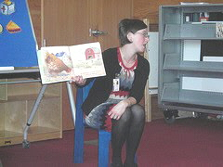 | The middle section of the program consists of a few books, rhymes, songs, and a felt board or clothesline story. Sometimes we even get out the shakers or scarves! Don’t worry, there’s a lot of moving around and dancing incorporated into the program because we know it can be hard to sit
  still for 20 or 30 minutes, even for us! When Miss Kristen tells us all to wave our hands up high and wave our hands down low, we know that it’s time to go, but not before Miss Erin has us also wave our ears, elbows, belly, and clothes. Then we all put on our happy faces and sing “If You’re Happy |  | 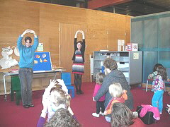
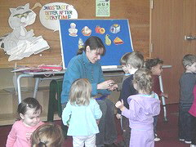 |  | and You Know It.”  Don’t forget to get a hand stamp before you leave, so when someone asks you where you got the cool frog or mouse stamp, you can tell them “at storytime”!

2

January 2011 Among Friends Volume V, No. 1 July 2011 Among Friends Volume III, No. 3

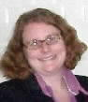 | A True Community Effort  By Holly McCullough, Manager,  Carnegie Library of Pittsburgh – Squirrel Hill  Since last year when the library board asked the community to step | Advocacy Alert –  In September, Secretary of  Education Tom Gluck  informed the library  community of an  additional 1.9% reduction  to the 2010-2011 public  library subsidy. This comes  on the heels of a July state  budget that reduced  annual operating funding  for Carnegie Library of  Pittsburgh (CLP) by 9.1%.  The reductions amount to  an additional annual cut  of $407,000 for CLP's 2011  budget on top of last  year's state budget  impacts, which reduced  CLP's annual operating  budget by $1.5 million.  That means that for the  foreseeable future, CLP  has lost nearly two million  dollars in annual support  from the state. This  reduction in state funding  is a major factor in the  Library's growing deficit  every year.  Right now is the time to call  Governor-elect Corbett  and tell him how important  libraries are to you and the  Commonwealth, and to  urge him to reverse this  alarming downward trend  in state funding for  libraries!  All things come to him who waits, except a loaned book.  Joubert Malcolm X, 1964 Malcolm X, 1964
up to save and support our libraries, the response has been overwhelming. Heroic efforts of library supporters and Friends have allowed us to maintain hours and locations throughout 2010 despite dramatic budget cuts from the state and flat budgets from the Regional Asset District.

The support of the community has been evident in a multitude of ways. Here are just a few examples:
- A great many people wrote letters and attended hearings for the Regional Asset District. The RAD increased our funding from their initial proposed budget of a 2% increase in September to 3% in their final approved budget! That helps us greatly in catching up with the shortfall from the 9% state budget cut this year.
- We’ve also done a tremendous job in increasing private donor support for the library. The Pittsburgh Foundation reported that the Carnegie Library was the single largest recipient of donations during its online Day of Giving. We raised $70,000 in one day!
- Squirrel Hill customers have purchased or renewed over $32,000 worth of donor cards this year in support of the library.
- There has been a tremendous rise in people interested in volunteering their time for the library. Ways that volunteers have really helped include shelving books as they’re returned, keeping the shelves in order, and helping to pull and prepare for shipping the daily list of items requested by patrons across the county.
- We kept the pressure and publicity on the Mayor’s office in support of the release of the $640,000 approved for the library by the City Council.

More than 1400 people attended or gave input as part of this summer’s community conversations on the future of the library. Thanks! And keep up these efforts to donate, advocate, and volunteer on behalf of your library.

Art at the Squirrel Hill Library  Our schedule is full through June, 2012. If you’d like to exhibit after that, contact Marion Damick, 412-521-3075.  3 | MISTICK …  In June, 2009 Among Friends reported a proposed 50% cut in state library funding, revealing a major crisis for CLP that continues. For a time, it looked as if several branches would be closed in 2011. Public protests and pressure lead to stop-gap money from the city and county, and formation of a public/private task force to find new sustainable ways to fund libraries. As Dr. Mistick told the Pittsburgh Post Gazette, “we were able to trim the budget around the edges, so we’ve cobbled together a solution for 2011... it’s not a long term solution…but the community has really stepped up and voiced its support to keep the system intact. The library is in the heart of every person in this community.”  Dr. Mistick has not yet decided on her next career step. “…I love Pittsburgh and I love the library and I am looking at other options that involve education in this city,” she said.
   | Coming up are:  January: Melanie Stefanic photos February: Yori Mudrenko oils  March: Ilene Yeager etchings,  prints

January 2011 Among Friends Volume V, No. 1

 | NAMM BUSINESS CENTER PROGRAMS  January – March 2011  by Dorothy Kabakeris, Namm Business Center Librarian  All programs are scheduled for Wednesday  from 10:15 AM – 11:00 AM | 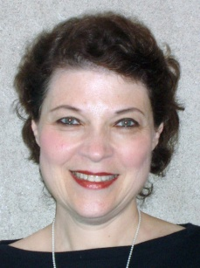

Wednesday January 26 @ 10:15 AM  Learn the differences between Wills,  Living Wills, and Powers of Attorney  and why the future of your assets may depend on them.  by Kathleen D. Schneider, Attorney, CPA.  *After the seminar, from 11:00 AM - 2:30 PM,  Attorney Schneider will give 30 minute personal reviews of your wills  and any other estate planning documents.  Please call Carnegie Library of Pittsburgh in Squirrel Hill  at 412-422-9650 for a personal appointment.  Wednesday, February 23 @ 1:00 PM  (note the changed time)  Find valuable information from library databases  at home at your fingertips including auto repair manuals,  biographies, authors similar in style to your favorite novelist,  magazine articles, and classical music on your PC speakers.  by Dorothy Kabakeris, Librarian, Carnegie Library of Pittsburgh.  Wednesday, March 23 @ 10:15 AM  Get all the home buying and selling tips  you'll ever need to buy or sell a house fast!  By Lois Harkness, Realtor, WHY USA Homes For U Realty, Inc  Sign up for the free electronic Namm Business Center newsletter, which announces the business programs in  Squirrel Hill & lists new business books: www.carnegielibrary.org/locations/squirrelhill/namm/ |  |  | In April 2005, when the library re-opened after renovation, the Namm Business Center was created and named after Dr. Allen Namm, who left a bequest to support the Squirrel Hill branch.  Dorothy Kabakeris, an experienced business librarian, has headed the Namm Center since it opened.  The business center has new books on starting a business, management and leadership, marketing and advertising, selling on the internet, real estate, investing, Wall Street, the economy, and advancing yourself in your company.  Two key investment newsletters are available: ValueLine for stocks and Morningstar for mutual funds.  SCORE business counselors offer free advice the first Monday of each month: 10:00 AM - 1:00 PM.
 | The Squirrel Hill Adult Book Discussion Group    Thursday, Jan 27 1:00 PM  Homer & Langley (fiction)  by E. L. Doctorow, 2009  Thursday, Feb 24 1:00 PM  The Guernsey Literary and  Potato Peel Pie Society (fiction)  by Mary Ann Shaffer &  Annie Barrows, 2008  Thursday, Mar 24 1:00 PM  Krakatoa: the day the world  The things I want to know are in books. My best friend is  the man who'll get me a book I [haven't] read.  Abraham Lincoln  exploded, August 27, 1883  by Simon Winchester, 2003 | Free Tax Services  Once again, Carnegie Library of Pittsburgh - Squirrel Hill will partner with the AARP Tax-Aides, volunteers trained by the IRS,  to offer free tax services to the public.  Tax service begins the first Tuesday in February and ends Thursday April 14, 2011. The schedule is Tuesdays, 12-3; Thursdays, 12-3  and Saturdays,10-3.  Please call the Library @ 412-422-9650 after January 17  to schedule an appointment with an AARP Tax-Aide.  The library also has available all the popular federal,  state and city tax forms.

4

January 2011 Among Friends Volume V, No. 1

 |  | Film,  Fiction, Fun  by Mark Russell,  Librarian |  | BOOKS,BOOKS,BOOKS,BOOKS,BOOKS,  BOOKS,BOOKS,BOOKS  by Margie Spenser  We took in $3300 at the October Clearance book sale and flea market, and as I write this the leftover books are finding |  | 
 |  | Film,  Fiction, Fun  by Mark Russell,  Librarian |  | new homes with local nonprofit organizations. Of course, as always our having a clearance sale was the signal for a flood of new donations, so drop in to our
Friends of the Library  raise money to supplement the library budget, advocate for library funding,  volunteer at the library, and  publicize library programs and events  The Friends of the Squirrel Hill Library  5801 Forbes Ave. Pittsburgh, PA 15217  412-422-9650  www.clpgh.org/locations/squirrelhill  friends@pittsburghusedbooks.com  Film, Fiction, and Fun is a special series presented at the Carnegie Library of Pittsburgh -- Squirrel Hill that explores the relationship between films and the novels that inspired them. Attendees are encouraged to read a monthly fiction selection, and then join CCAC’s Jeanne Bergad for a screening of the film and discussion to follow. |  |  |  |  | workroom and help us sort books. We’ll start you out gently; even 15 minutes’ help is a boon to us.  Setting up for the sale was a pleasure, compared to previous years. We took two days to do it this time, and we had many excellent volunteers. In addition to our stalwart Friends – John Henry Harrison, Bill Jones, and Bob Shapiro – we again had a crew from the Job Corps who lugged boxes and filled tables with books as one of their com- munity service events.  During the sale itself, we had very welcome help keeping the books in order from members of the

January 20th’s title is Macbeth, by William Shakespeare. Believed to have been written sometime between 1603 and 1607, Macbeth is one of Shakespeare’s most famous tragedies. The titular character, a general in the army of Scottish King Duncan, allows prophecy and ambition to convince him to commit regicide. Akira Kurasawa’s 1957 film Throne of Blood (Kumonosu-Jo) is a re-telling of the story of Macbeth set in 16th century Japan. The film stars Toshiro Mifune and Minoru Chiaki. | junior high Sunday school class at the Unitarian Church, and several high school women who have chosen helping the Carnegie Library as their senior year project. And I can’t forget the many Friends who said “Of course!” when Anita Newell called them (again!) to ask them to staff the Cashier’s table. Thanks to all of you – we couldn’t do it without you.  Our Friends’ President and newsletter editor Joan Schwartzman had a bout with pneumonia and was back in the hospital when we started work on this issue. Okay, Joan, enough goldbricking!! We miss you.

February 17th’s selection is Romeo and Juliet, by William Shakespeare. Shakespeare’s second most-performed play (after Hamlet) is believed to have been written sometime between 1591 and 1595. The two title characters are children of feuding families who fall in love at first sight, with tragic results. The American musical West Side Story is a modern adaptation of Romeo and Juliet, in which the feuding families are replaced by rival gangs in 1950’s New York. The film version of West Side Story was released in 1961, starring Natalie Wood, Richard Beymer, George Chakiris, Rita Moreno, and Russ Tamblyn. Robert Wise directed the film, and it holds the distinction of winning more Academy Awards (10, including Best Picture) than any other musical film.  The only books that influence us are those for which  we are ready, and which have gone a little farther down our particular path than we have yet got ourselves.  E.M. Forster  March 17th’s novel is The Trial, by Franz Kafka. Originally published in 1925, The Trial is one of Kafka’s best known works. The protagonist of the story, Josef K., is a bank clerk who is arrested on his 30th birthday for an unnamed crime. His arrest becomes more and more mysterious as he descends into the shadowy bureaucracy of the legal system. The 1962 film version of The Trial was directed by Orson Welles, who also appeared in the film as the Advocate (a part originally intended for Jackie Gleason). Anthony Perkins played the starring role of Josef K. | got ourselves.
  Film, Fiction, Fun  third Thursday of the month from 1 to 4 p.m. | led by 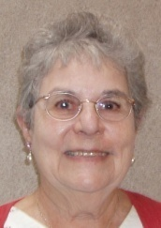  Jeanne  Bergad
  January 20 Throne of Blood based on
  Macbeth by William Shakespeare
  February 17 West Side Story based on
  Romeo and Juliet by William Shakespeare
  March 18 The Trial
  by Franz Kafka
 | 

5

CARNEGIE LIBRARY OF PITTSBURGH  SQUIRREL HILL |  | 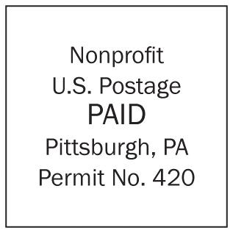  Look! A  membership  card!
5 8 01 Forbes Avenue  Pittsburgh, PA 15217  Adult Services: 412-422-9650  Children's Services: 412-422-9841  Fax: 412-422-5811  www.carnegielibrary.org/clp/sq  Is your Friends Membership  up to date? If the date is before  01/11, you need to renew.  Use the form below.  If your email code is “I” or blank,  please send us a valid email address at friends@pittsburghusedbooks.com. | ADDRESS SERVICE REQUESTED  your donation is tax deductible as a charitable contribution
  
  «exptext»  «expdate»  email code: «em» | «first» «last»  «addr»  Pittsburgh, PA «zip»«zip4»
I’m so busy, I don’t know if I’ve found a rope or lost my horse.

January 2011 Among Friends Volume V, No. 1
 | 2011 SALES  Jan 21-23  Everything Old is  New Again  Feb 17-19  Black History  Month  March – no sale  April 28- 30, May 13  Spring Cleanup  May 18-20 -- ??  June – no sale  July 14-17  Fiction/A-V/  Foreign Language  August – no sale  September 22-25  Religion/Philosophy/  Judaica  October 28-31  Fall Clearance Sale  November 17-20  Holiday Shopping  December – no sale | Make checks payable to:  Friends of the Squirrel Hill Library  and mail to:  Margie Spenser  5900 Douglas St  Pittsburgh, PA 15217  Check one box:  New Member Renewal  Check one or two boxes:  $5.00 $10.00 $15.00  $25.00 Other _____  DONOR (free, but we accept donations)  Name:___________________________________  ^{(Last)} ^{(First)}  Address: _________________________________  City/State: __________________Zip: __________  Phone(s): ___________________Date: _________  E-mail address: ____________________________  Please check all activities you can help with:  Periodic Book Sales Library Advocacy  Sorting Used Books Gardening  Adopt-a-Shelf Program Newsletter  COMMENTS_______________________  ______________________________
6

